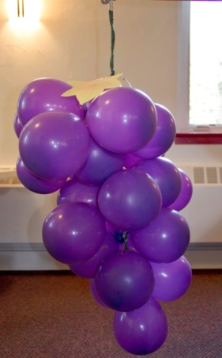

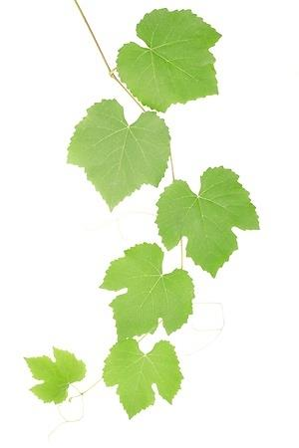

# Get the Grapes Review Game Prepare this game by writing review questions from your Bible lesson and class hour on small individual pieces of paper (one question on each piece of paper). On the back of each question, write a number of points. Put each question into a purple balloon, blow it up, and tie it shut. Tie the balloons together to form a cluster of grapes and put them on a pole. Tape the leaves to the top of the cluster.

To play the game, divide the class into two teams and have each team form a line. Ask the first child in Team 1’s line to come up and pop a balloon, using a straight pin. If he answers the question inside correctly, his team gets the number of points that is written on the back. If not, the other team gets those points. Repeat this procedure with the first person in line from Team 2, then the second child in line from Team 1, then the second child in Team 2’s line, and so on until every child has had a turn or you run out of balloons. Add the points for both teams to see which team has the highest score.