

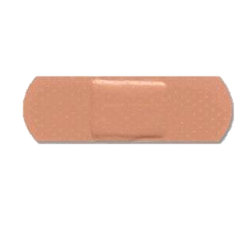

# Get the Band-Aids!

Print two copies of the wounded man and bring a box of band-aids to class. After the lesson, divide the class into two teams. Give each team six band-aids, assign them one of the wounded men, and explain that their injured man needs help FAST!

Divide the class into two teams. Ask a review question. The child who raises his hand first and gives the correct answer gets to come and put one of his team’s band-aids on its wounded man. Repeat this process until one of the teams has applied all of its band-aids. Announce that team to be the winner!