Creation Object Lesson
The next time your watch stops working, don’t throw it away! Instead, let your son take it apart and put it into a small clear box (like I did). It makes a great object lesson for teaching God’s powerful work of creation.
Many children are being taught that our world and everything in it “just happened” over billions of years, slowly evolving into what we see today . . . all by random chance. That is totally impossible, as this object lesson will clearly show your students. Give the box of watch pieces to one of the children and ask him to shake it until it becomes a watch that you can wear again and read the time from. Wait with all the children to see if that will happen. Obviously it won’t, but give it to another child and let him try. Ask them if they kept shaking for a hundred years (or a thousand . . . or a million), would the watch come together properly? Even if it did, would it run accurately? Of course not! But that is what some people are trying to say happened to the earth and all that is in it. The watch is easy compared to a zebra or a bird . . . or a human being! When we tried to “make” our watch, we already had all the pieces we needed to make it happen. God didn’t! He started with nothing. Our God is the only one who is intelligent and powerful enough to make our world (Genesis 1).
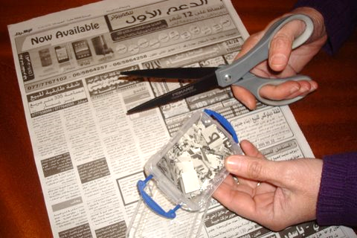
Variation: The same lesson can be taught by using a page from a newspaper and cutting each letter apart. Put all of the individual letters into a small box. You can shake it forever and it will never come back together to make the same page you cut. Our God is an awesome Creator!!

