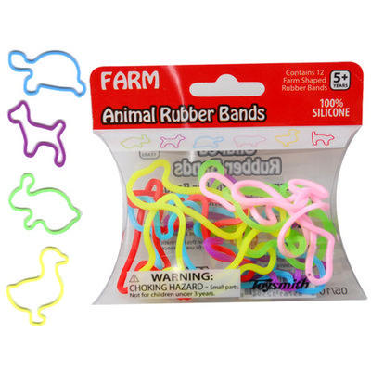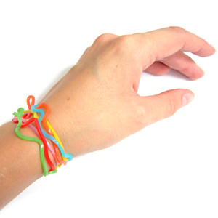

Right-armed Band-it  
(Idea from Sharron Oyer)

Give each child three loose-fitting rubber bands (or silly bandz) to place on his left wrist. Ask a review question. The child who stands first and gives the correct answer gets to switch one of his bands to his right wrist. Continue to play until one child has all three bands on his right wrist. Give him a prize for being the winner!  
  
Variation: Divide boys and girls into teams. Place rubber bands of several colors in a bag. Choose one   
 color such as red to represent “snap.” Place two of that color in the bag. Assign point values   
 to all colors except for the one which will be “snap” (meaning you subtract all points).   
 *Example: A child answers a question correctly, reaches in the bag without looking, and   
 draws out a red band. His team must return all their bands to the sack and start counting over.*