***Sharing God’s Love  
Through the Wordless Book***

**GIVE AN INTRODUCTION**

1. Introduce yourself (start building a relationship)
2. Introduce the *Wordless Book*

* WB*“What’s different about this book . . .”*
* *“Would you like to hear a story from this book . . .”*
* *“It’s true because it comes from God . . .”*

God2CloudLoveCloudHolyHeaven

This gold color reminds me about heaven . . .

**Heaven**

*Describe things that are in heaven and things that are not in heaven (Revelation 21,22)

*In Heaven Not in Heaven*

The best thing about heaven is God is there . . .

1. God is love **(God loves you and me)**

*Jeremiah 31:3*

*Define God’s kind of love: He always does what is best for you

*Describe characteristics of God’s love

* It is everlasting
* It is for everyone
* He wants you in heaven some day

2. God is holy—meaning He’s pure, right, good, makes no mistakes

***Link to next color: “****God loves you and wants you to live in heaven, but there is one thing that will keep   
 you out . . .”*

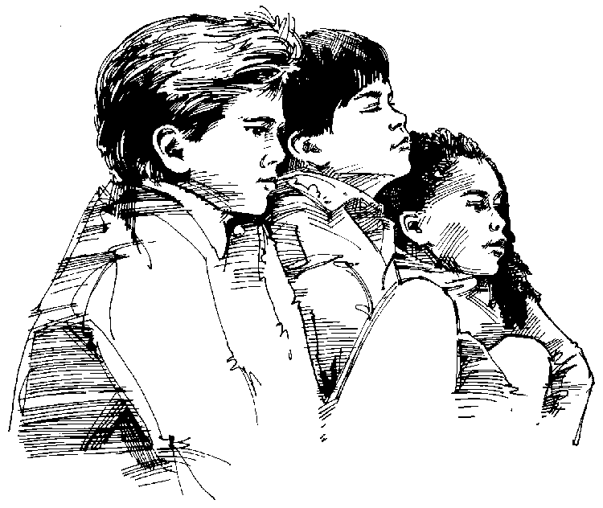Heart 16Separate

This red color reminds me of the One God sent to take your punishment for you . . .

**Who is Jesus?**

1. Jesus is God

*He is holy . . . love . . . eternal

*One day He left heaven and came to earth to do something for you

1. Jesus is man

Jesus was born as a baby . . . like you were . . .

The only difference is ***Jesus had no sin***

**What did Jesus do for you?**

1. Jesus died for your sins

1 Corinthians 15:3,4

*Describe substitution: He took the punishment you deserved. He gave His   
blood . . . His life for you. You should have been punished, but He was for you.

1. Jesus rose from the dead . . . and is now in heaven.

***Link to next color:*** *“Because Jesus died for your sins and rose again, there is something that He can   
 give you . . .”*

This dark color reminds me of what will keep you out of heaven—**Sin!**

Define sin:

All have sinned **(you and I have sinned)**

*Romans 3:23*

Give specific examples appropriate to the age of the child:

√ A “thinking” sin: __________________________________________________________________

√ A “speaking” sin: _________________________________________________________________

√ A “doing” sin: ____________________________________________________________________

A holy God must punish sin. The punishment for sin is death (separation from  
 God forever)

***Link to next color:*** *“You deserve to be punished for your sins forever, but this next page reminds  
 me of what God did so you would not have to be punished . . .”*

God2

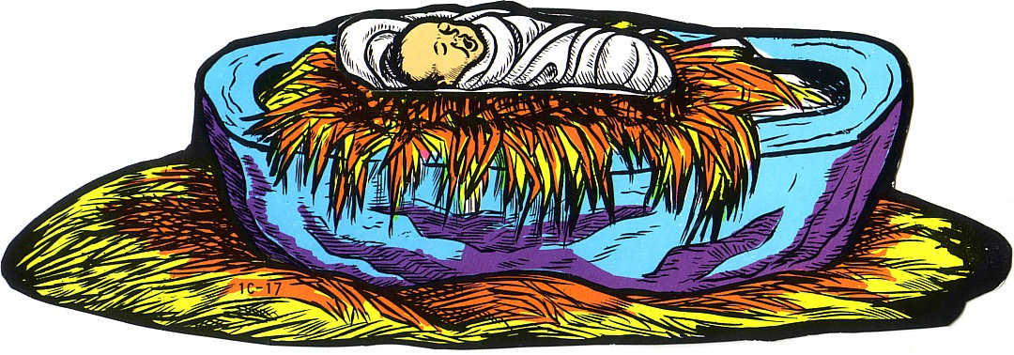

Cross2

Tomb

Question2OpenBible4CLNHART

This clean color reminds me of the special gift Jesus wants to give you today . . .

**Describe the new clean life**

This is a new kind of life He wants to give you. It’s the kind of life that:

1. You need to get into heaven
2. Gives you power to say “no” to sin and temptation
3. Gives you power to say “yes” to things that please God
4. Lasts forever

Explain a condition/promise verse on salvation

*Verse Condition Promise*

*John 3:16*

*John 1:12*

*Acts 16:31*

*To Believe on Jesus means you need to:

**Admit** . . . you have sinned

**Believe** . . . Jesus died for your sins

**Choose** . . . for Him to give you a new clean life

*When you believe in Jesus . . . He will keep His promise from the verse.

***Would you like to believe on Jesus right now?***

Tutorial 6

***Wordless Book Checklist—1***

Starting Time: ________________________ Ending Time: ________________________

_____ Introduction

_____ Link

CloudLoveCloudHoly

_____ Heaven

Heaven2 _____ Establish Who God is

_____ God is holy

_____ God is love

God2 _____ Verse: _________________________________

_____ Link

Separate _____ Definition

_____ All have sinned

_____ “You” have sinned

Man _____ Verse: _________________________________

_____ Example

_____ Example

_____ Example

_____ Punishment

_____ Link

God2

_____ Jesus is God/perfect

 _____ Jesus is man

_____ Jesus died in your place (substitution)

CrossTomb _____ Jesus rose again

_____ Verse: _________________________________

_____ Link

CleanHrt _____ New life explained

C~Pverse _____ Condition/promise verse: _________________

_____ Condition explained

_____ Promise explained

_____ Invitation question

Teacher: _______________________________________________________________

Listener: _______________________________________________________________

Date: __________________________________________________________________